How to add an image to a calendar event

*The instructions assume you are using Google Chrome.*

1. Visit <https://unsplash.com> (a site with thousands of free images). You can also visit <http://pages.nichols.edu/calendarimagery> to choose Nichols-specific images.
2. In the Search bar, enter your search phrase to find related images that you can use.

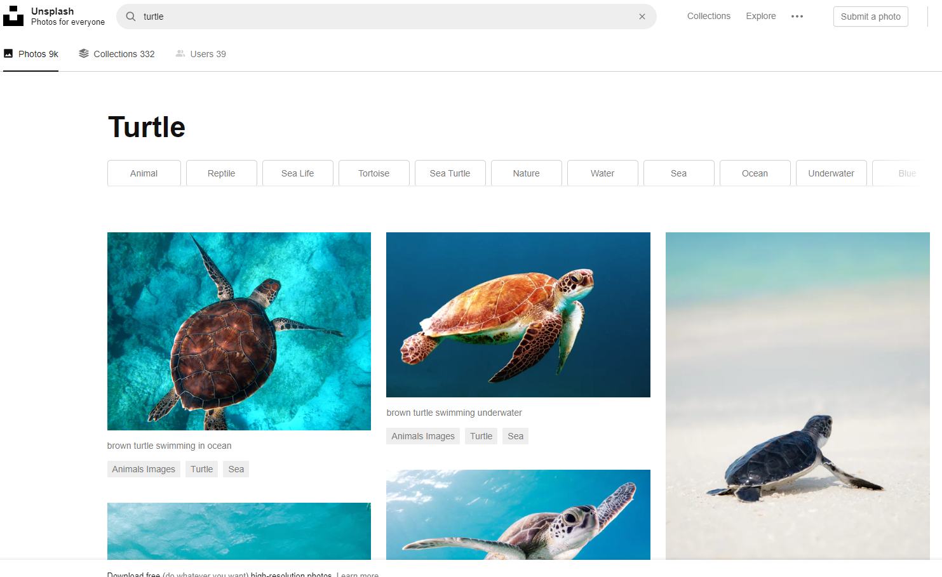

1. Browse through the images to find the one you would like. Right-click the image and choose “**Copy Image Address**” (do not choose “Copy Link Address”).
2. To verify the image address works, open a new browser tab and paste the URL into the address bar; you should see the image as it will appear in your calendar item:

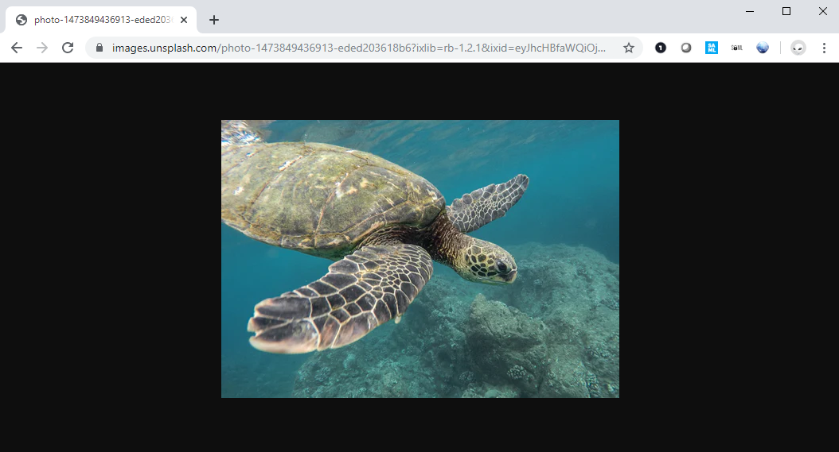

1. In 25Live, complete the Event Wizard. Check the box beside “**Detail Image**.” Right-click in the text box and Paste the URL you copied from Unsplash.com. Then complete the Wizard as normal.

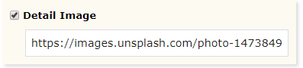

1. When your event has been approved, the image will be displayed along with your event details.

