Student Self-Service Proxy Access
Students can grant access to their accounts from within Self-Service using the “View/Add Proxy” feature. This allows other people, called “Proxies”, to access to the student’s records for things like:
- Viewing student statements
- Making a payment
- Viewing grades
To grant someone else Proxy access to your student account in Self-Service:
- Login to SelfService from OneLogin.
- Click on your username in the top right corner and choose “View/Add Proxy Access”
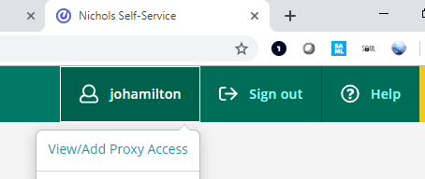
- If you have any existing Proxies, they are listed under “Active Proxies”. You can come to this page at any time to edit access for your existing Proxies.
- To add a new Proxy, choose the person from the “Select a Proxy” drop-down. If the person isn’t listed, choose “Add Another User” and fill in the name, email, and other information about the person.
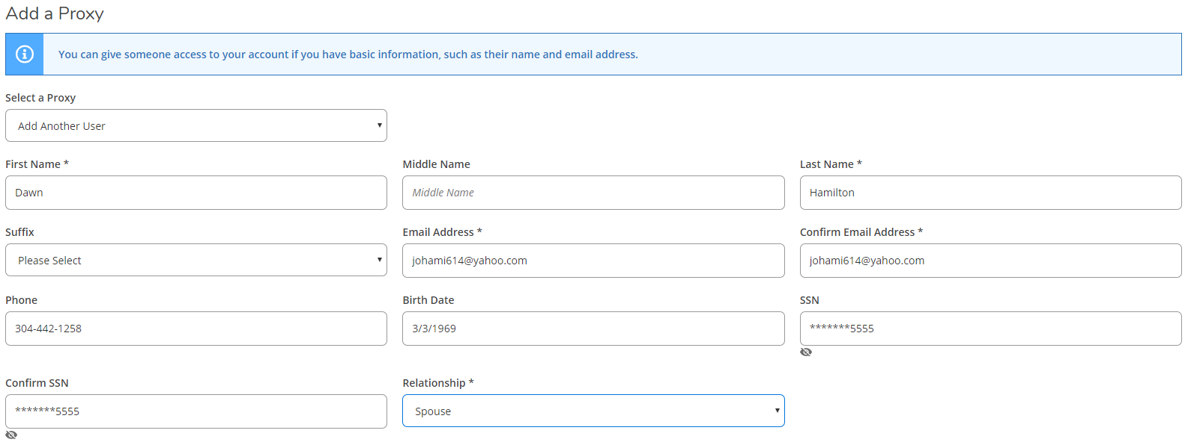
- Choose the level of access you want the Proxy to have by checking the appropriate boxes.
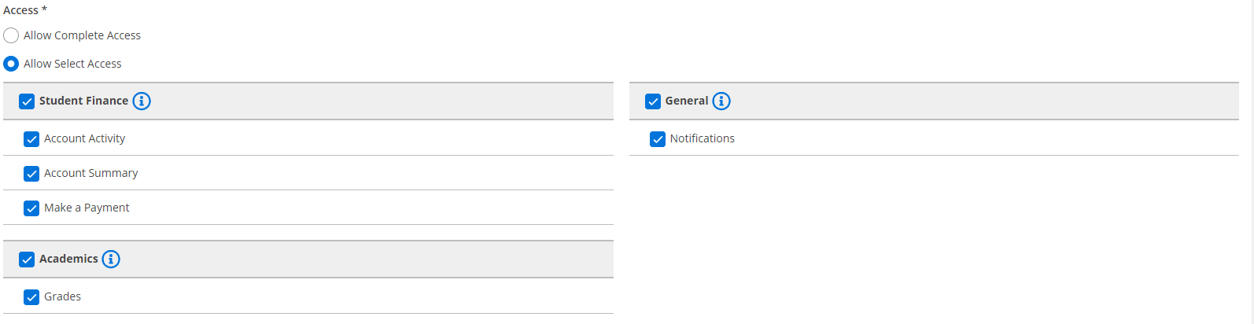
- After reading the Disclosure Agreement, check the box below and click Submit.
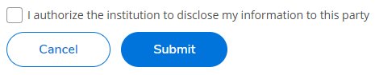
- You will then see a confirmation message stating whether or not the Proxy user was found in our system; click Continue to give the user access or Cancel to go back.
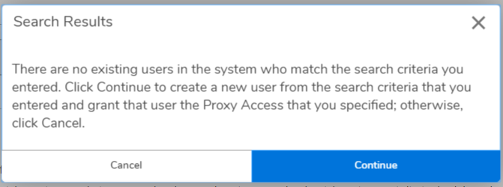
- The Proxy will receive an email with their username and instructions for resetting their initial password and accessing your records in SelfService; you will also receive a copy of this email as confirmation that access has been granted.
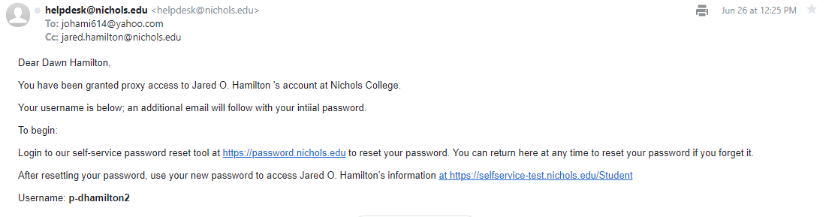
- Your Proxy will receive a second email with their initial password. For security reasons, you will not receive the password via email.
